INSY 3305 - 003

Dr. Ganapathiraman Raman

Group #16

User Role for Group #15

Designer Role for Group #7

Aesha Mohamed

Sumayya Shirwa

Anwar Abu

David Ezeji

Project Final Deliverable

**Rate My Surgeon**

**A) Introduction**

The goal for the project is to create a platform where previous patients can rate their doctors to make it easier for those in the area who are looking for a good surgeon. This platform will ensure a better surgery and after surgery experience.

**B) System Request**

This system requires creating and providing a platform for users to rate their previous surgeons. Once this project is initiated, patients will find surgeons faster while also finding the best surgeon who meets their needs, and as a result will create more satisfaction and ultimately decrease the negative side effects felt post operation.

**Project Sponsor**

The project sponsors who have the key management role in this system is Yelp.

**Business Need**

This system is a crucial part to the healthcare industry because it aids in the process of finding a surgeon for an important surgery. Currently, there is no platform that has all surgeons listed in the same catalog. The goals and objectives of this system is to give users access to surgeons in every hospital across the United States so they will see how much options they have, on a local level as well as a national level. This will let users find the best surgeon match they are most confident in, which can help them avoid negative after surgery side effects.

**Business Requirements**

Users who wish to review are required to register an account and to use their real first and last name. However, those who do not wish to review can choose to continue onto the site as a guest. This allows ratings to be filtered and make sure that only patients that have been treated by the surgeon can post ratings. As a result, ratings cannot be anonymous, because surgery is a serious topic and can be a matter of life to death.

Surgeons cannot rate themselves or reply to their ratings, so there should be the option to create an account as a surgeon. While registering, they should provide proof that they are a surgeon, so they can be given different features. Among those features are the inability to post reviews and the option to contact the platform and ask a review to be taken down if they did not previously work with the patient leaving a review. Bad ratings, however, cannot be taken down.

The users must agree to let the creators of the system monitor and regulate their reviews, that should be made clear as soon as they create their account. Giving the creators the power to regulate comments will prevent foul language or any violations of any medical standards such as HIPAA. If the creators feel that a review does not align with their goal for the platform, then it can be taken down without their consent. If the same user violates this multiple times, their whole account will be taken down. These requirements must all be met for the goals of the system to be met.

**Business Value**

The user registration requirement will filter out false or spam reviews as well as create a process for surgeons to identify previous patients as they read their reviews. The requirement to create different user interfaces will allow the platform to have a wider range of use, both for patients and surgeons. Since the system requires reviews to use their real names, users cannot slander or defame, thus reducing the chances of legal action being taken against the platform. A system that has the capabilities mentioned above will satisfy the need for a platform that helps patients secure the ideal surgeon as soon as possible, while simultaneously diminishing negative side effects of surgery.

**C) Technical Feasibility**

The factors that are in the functional area are the cloud, portal login website, and architecture/design. The risk that is associated with the cloud is mainly issues surrounding data integrity. Unauthorized individuals can access the system’s information and to prevent that we can have multiple factor authentication, make backups, and encrypt data. We can also constantly check on information stored in the cloud and keep track. Ultimately, this prevents data from being stolen. As for the system’s portal login, there could be the risk of users using weak credentials and hackers can steal a user’s login information and as a result their personal information. To prevent that from happening we can set up password requirements that need to be met. Regarding the website, the main risk is it being prone to hackers, but it could also crash due to a large number of reviews or users using it at the same time. To prevent that from happening, we can encrypt the website using HTTPS and protect it with the latest software. Lastly, the risks concerning the architecture or design of the system are failure and flaws in the design itself. To prevent that from happening we would refer to using the peer review process to limit risks.

**D) Economic Feasibility**



**E) Break Even Graph**

**F) Organizational Feasibility**

To make sure the users do not have any issues and accept our system, we have analyzed all the risk and who it may affect. The stakeholders in the system would be the surgeons, current or previous patients, as well as the users. The risks that surgeons might have would be certain surgeons might get more clientele as opposed to other surgeons. To prevent that, those surgeons that are not receiving as many patients can better their skills and start getting new patients again. In regard to current or previous patients, they can be working with a specific surgeon and have a good experience but then they read negative reviews and are hesitant to go back. To reduce that risk, we would give the disclaimer on the web page that these are just reviews not professional evaluation. As for users looking for a new surgeon, they might feel uncertain with their surgeon if they don’t have a review, we can reduce the risk by encouraging patients to review their surgeons through advertising.

**G) Designer Combined Functional Requirements**

1. Determining whether to create account.
   1. Choose to continue as guest if not reviewing.
   2. Move on to create account if posting a review.
   3. Filter on location and surgery type (plastic, neural, dental, etc.)
2. Creating Account as a patient
   1. Access in any platform mobile laptop iPad etc.
   2. Choose to create account as a patient.
   3. Enter first and last name to verify that user was a patient with surgeon they are reviewing and post the date of surgery with doctor to help with verification process.
   4. Users agree to let creators monitor their comments.
3. Creating account as a surgeon
   1. Choose to create account as a surgeon.
   2. Enter first and last name.
   3. Enter information needed to verify that you are a surgeon.
   4. Access to analytics and reporting tools which allows the surgeon to analyze their performance, track patients feedback, and identify areas for improvements.
4. Posting a review
   1. Determine whether user is patient, or surgeon.
   2. Patients can post reviews and use a 5-star rating system to review certain categories.
   3. Surgeons cannot post reviews.
5. Taking down false reviews
   1. Surgeons complain about false reviews.
   2. The information will be reviewed.
   3. If it’s true the comment will get taken down, otherwise it stays up.
6. Regulating comments
   1. Creators take down comments that are harmful, defamatory, or violate any medical guidelines.
   2. Users with multiple offenses will get account taken down.

**H) Non-Functional Requirements**

1. Portability
   1. Includes the hardware and the software.
   2. Reduces cost for manual labor.
2. Reliability

2.1 Requires backup daily so information doesn’t get lost.

2.2 Makes sure that mistakes are not made when uploading a review.

1. Security
   1. Sensitive information’s are kept secure.
   2. Surgeons can’t see the patents name who left the review.
2. Localization
   1. Makes sure to target the right audience.
   2. Shares use of local language and spelling to the user who’s submitting a review.
3. Usability
   1. Indicates how effectively can our users use our system.
4. Maintainability
   1. Updates the system when its necessary.
   2. Makes sure that the system doesn’t go down for a long period of time.

**I) Designer Functional Requirements Traceability Matrix:**



**J) Use-Case Diagram:**



Creator



Patient



Surgeon

**K) Activity Diagrams:**

Activity Diagram #1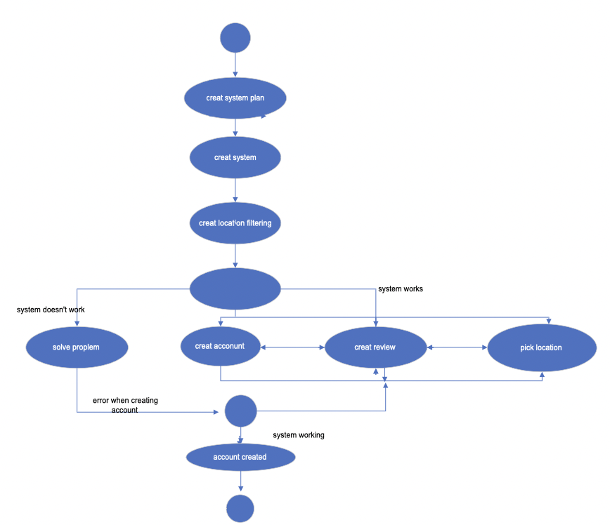



Activity Diagram #2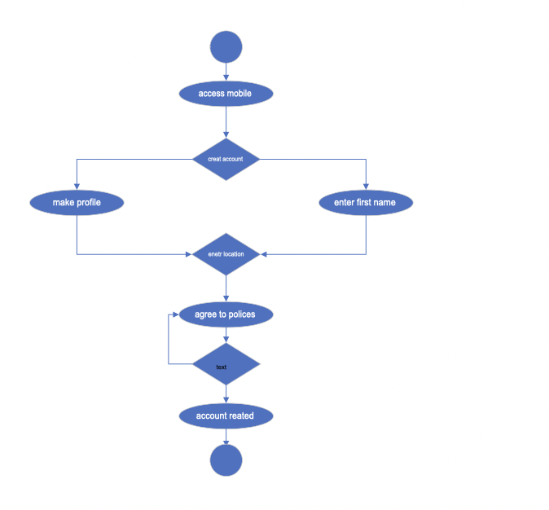

Activity Diagram #3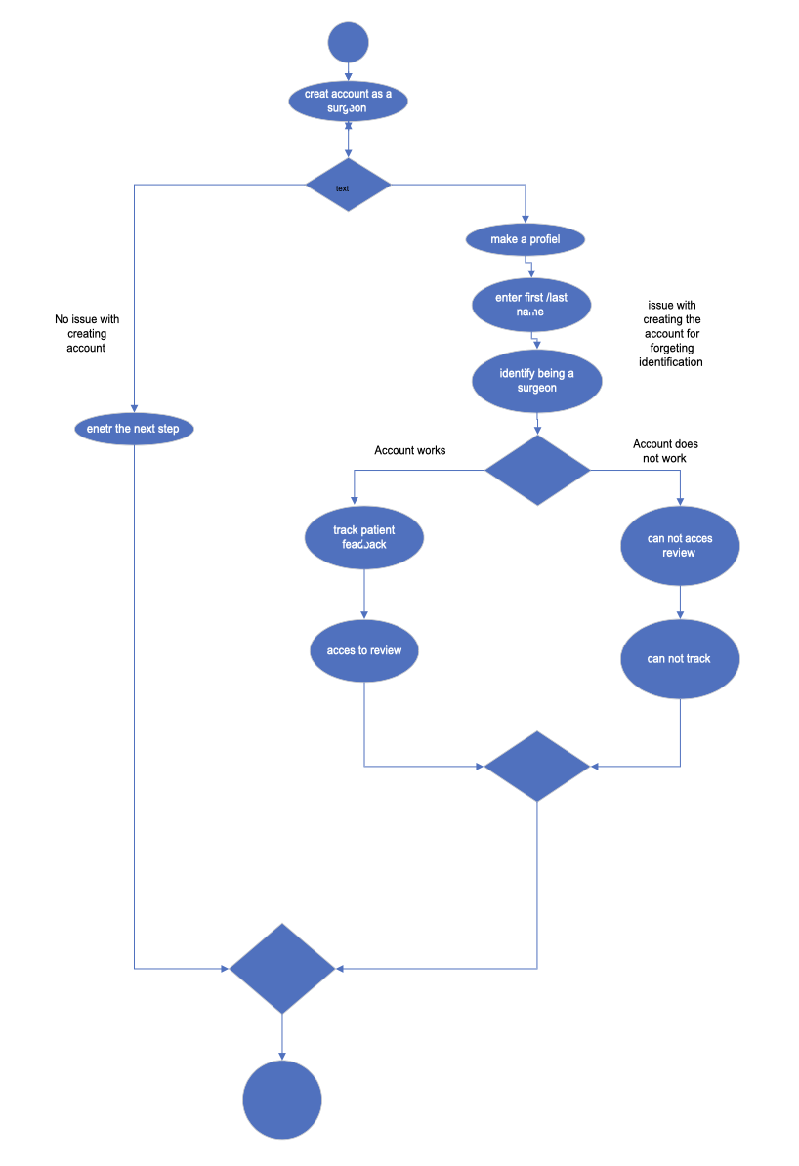

Activity Diagram #4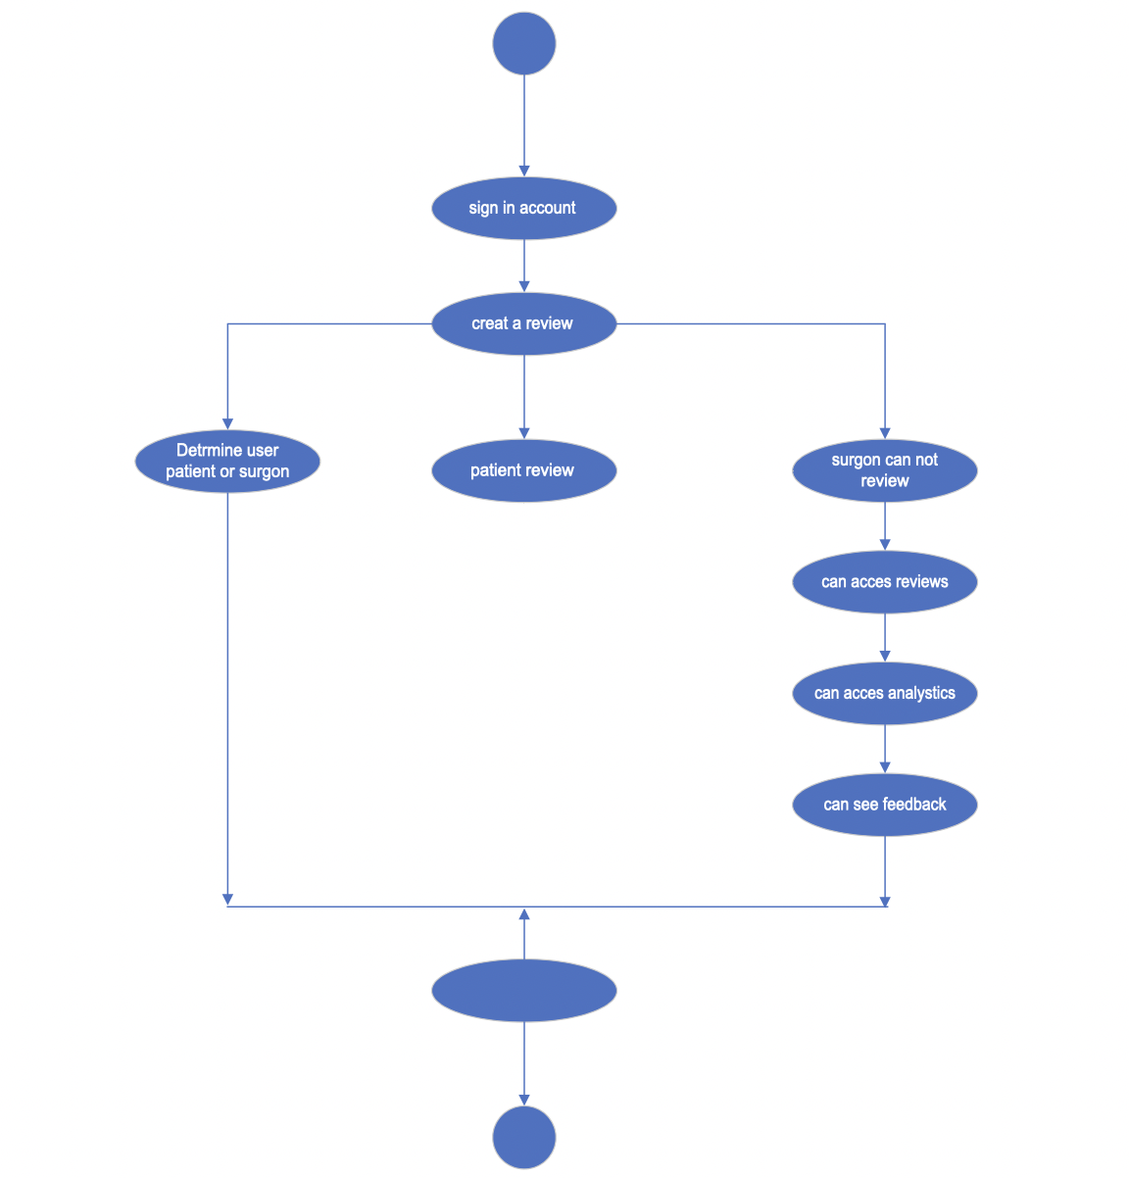

Activity Diagram #5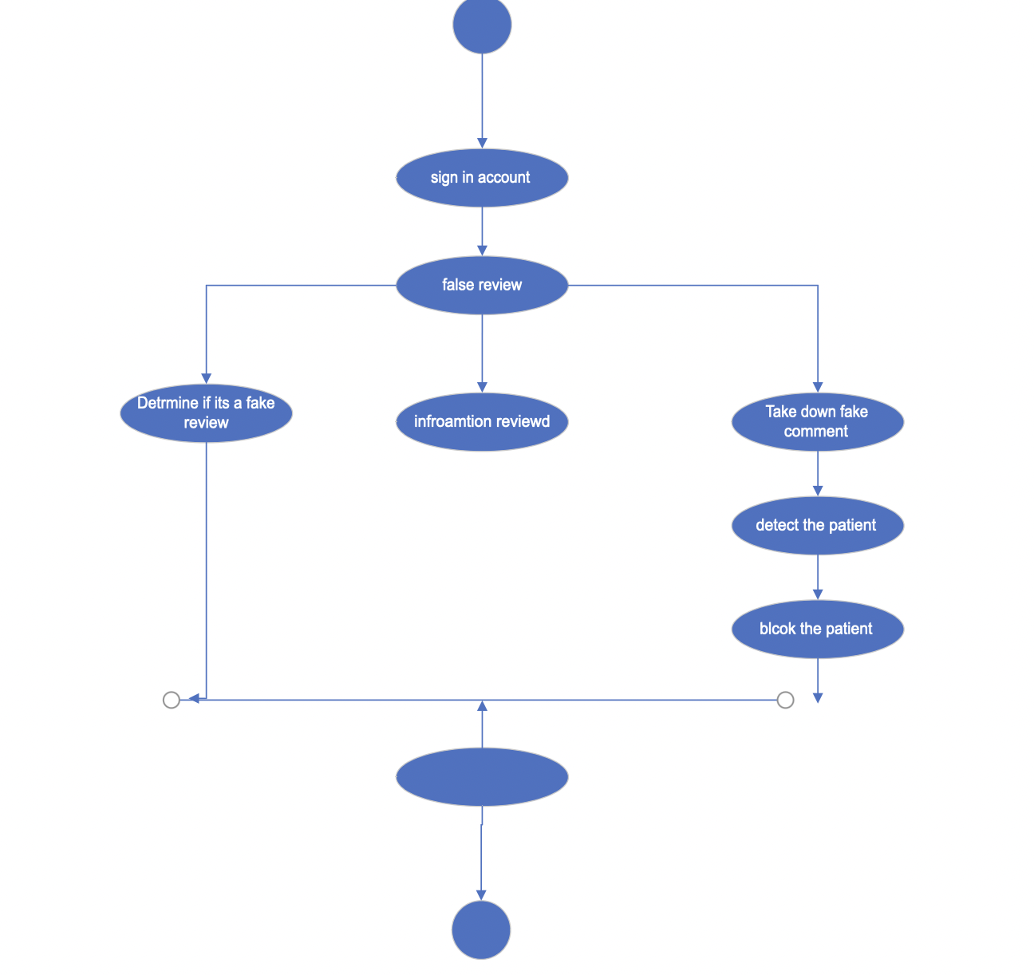

Activity Diagram #6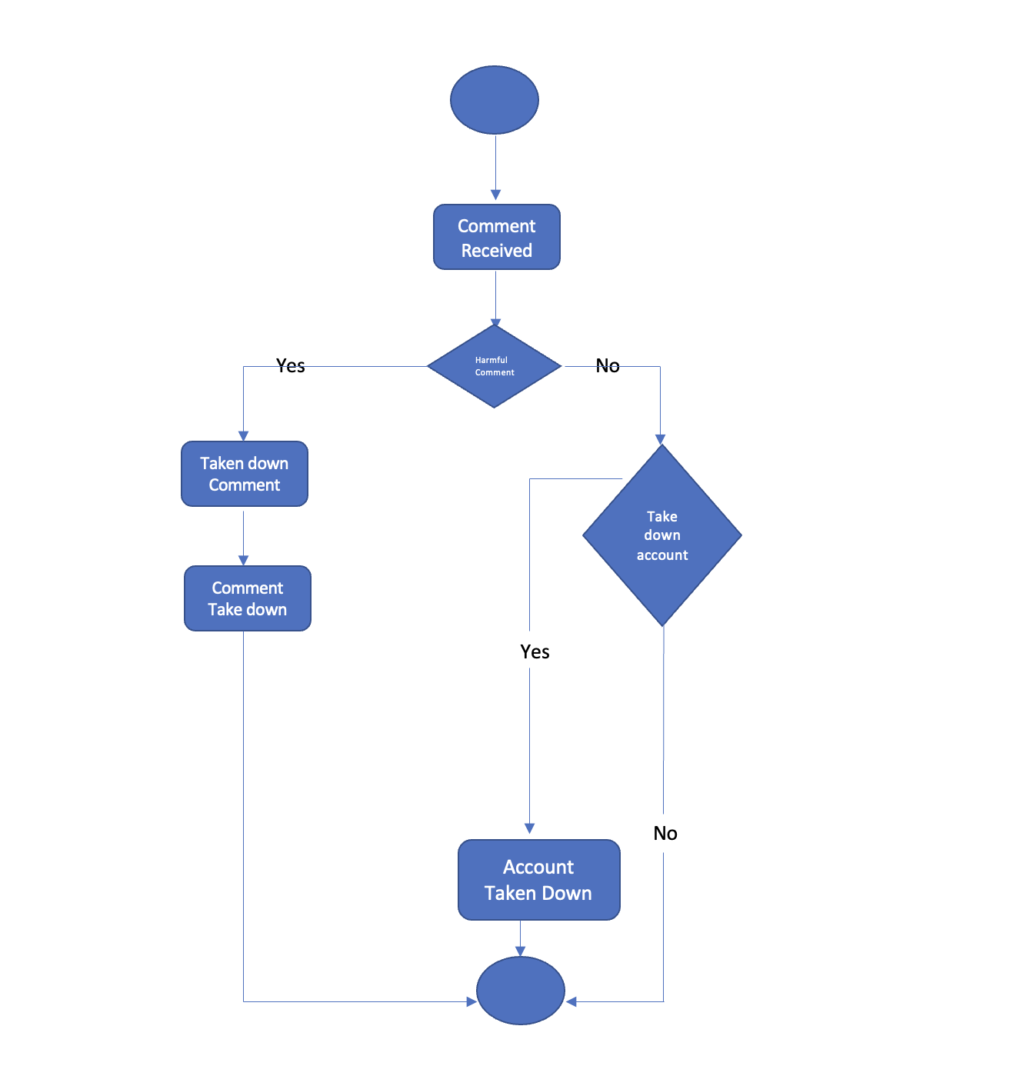

**L) Use-Case Descriptions**

Use-Case Description #1

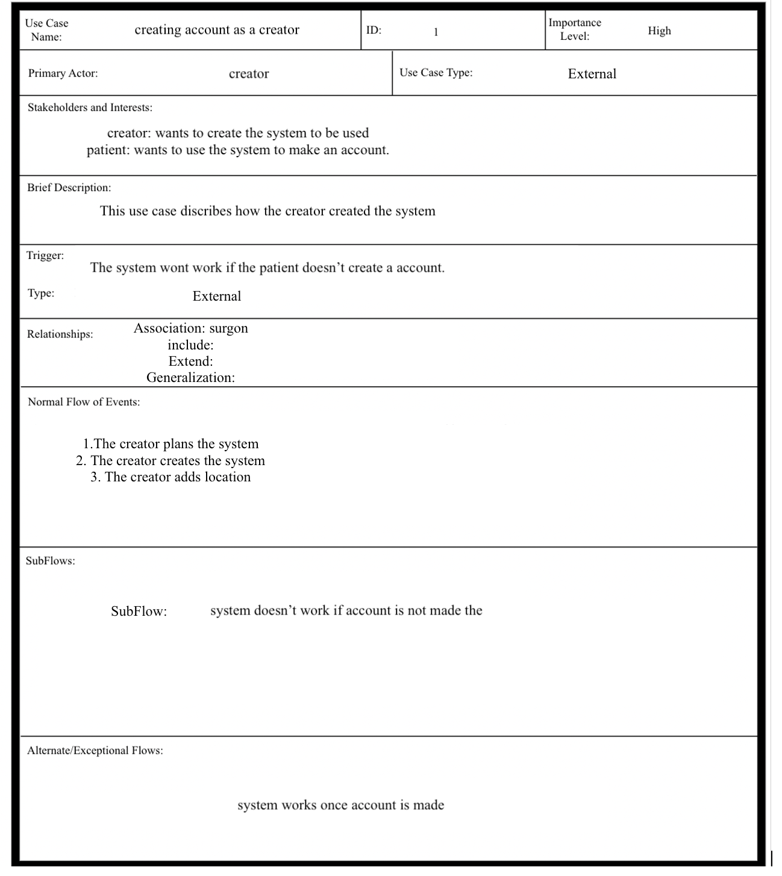

Use-Case Description #2

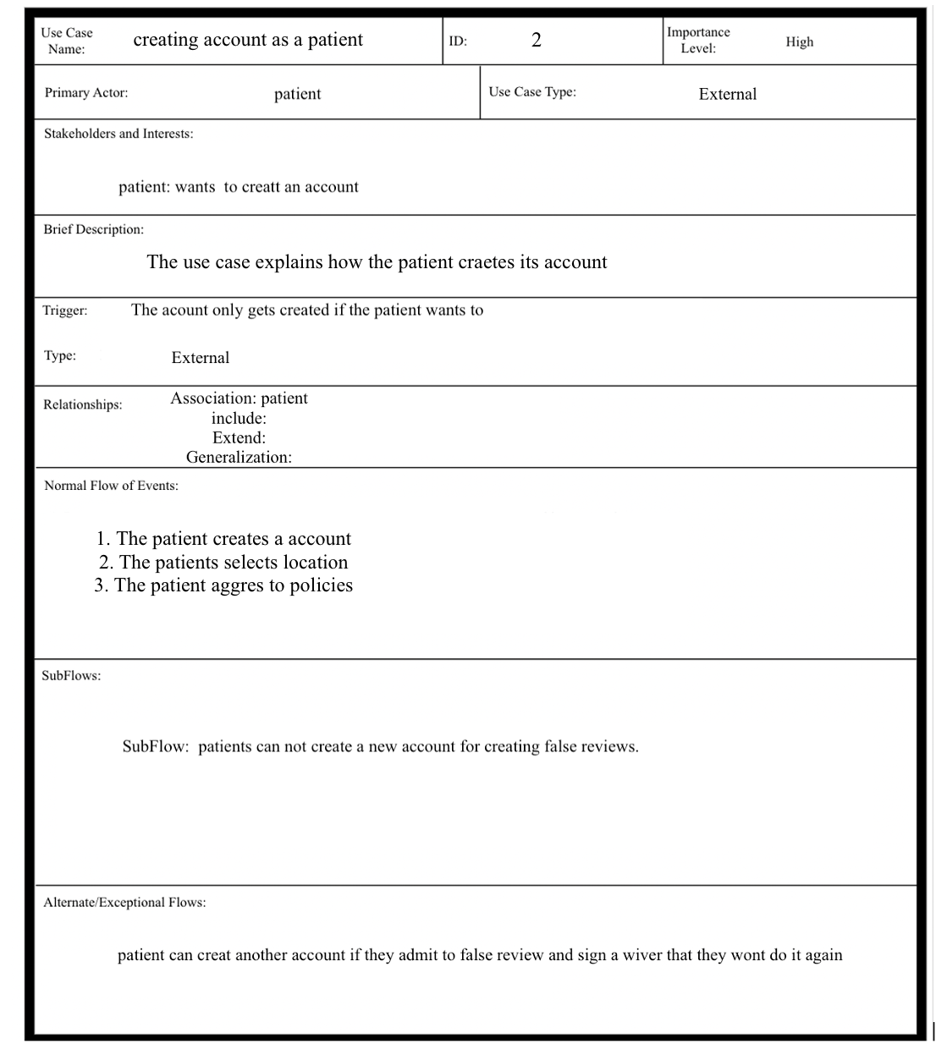

Use-Case Description #3

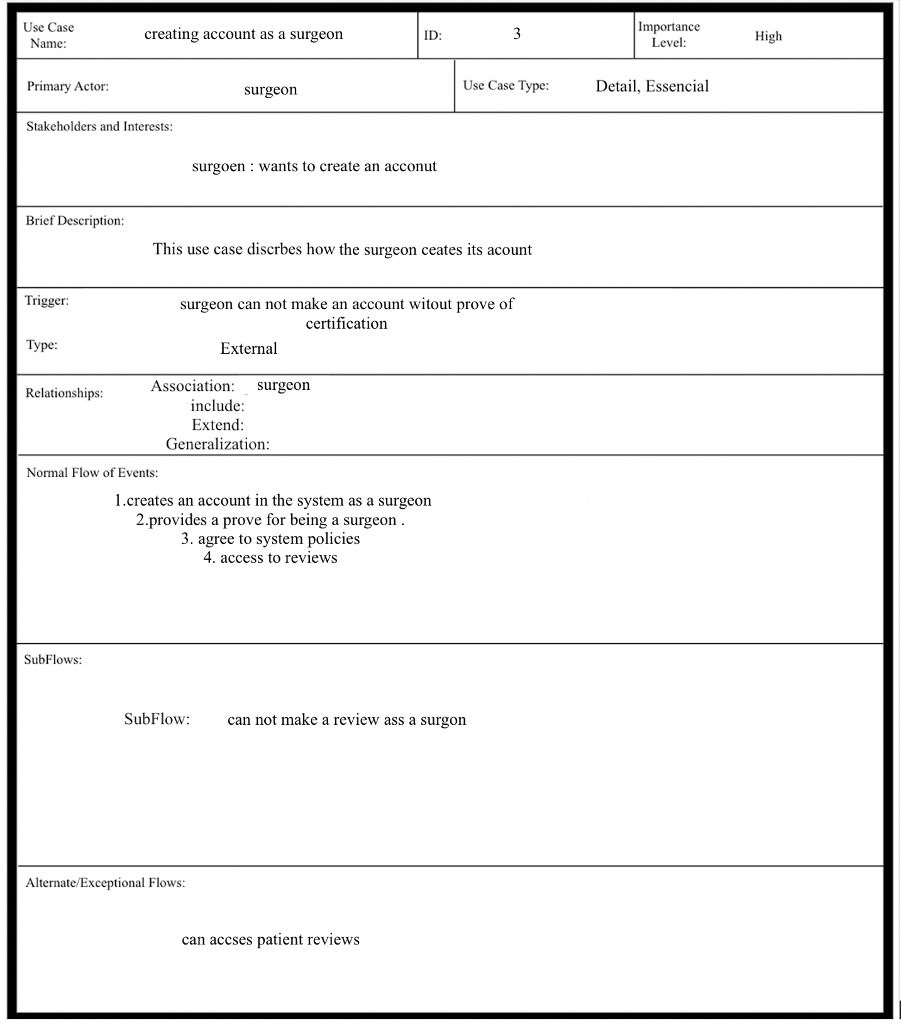

Use-Case Description #4

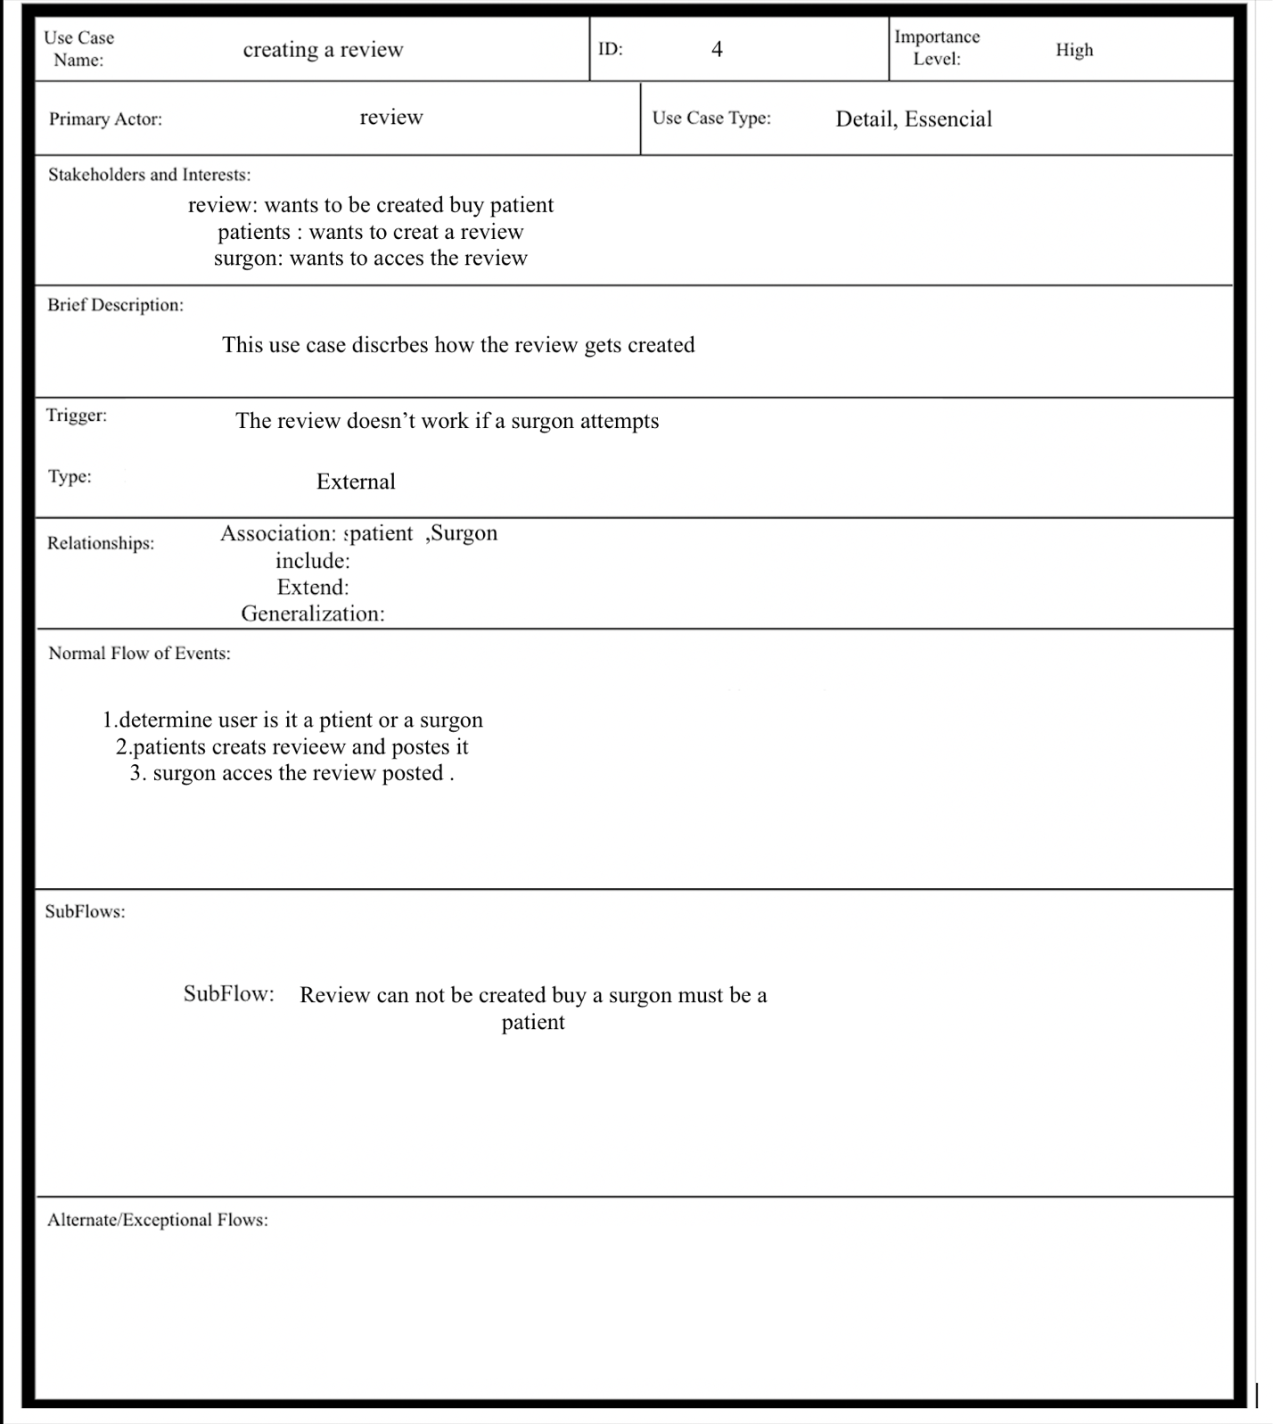

Use-Case Description #5

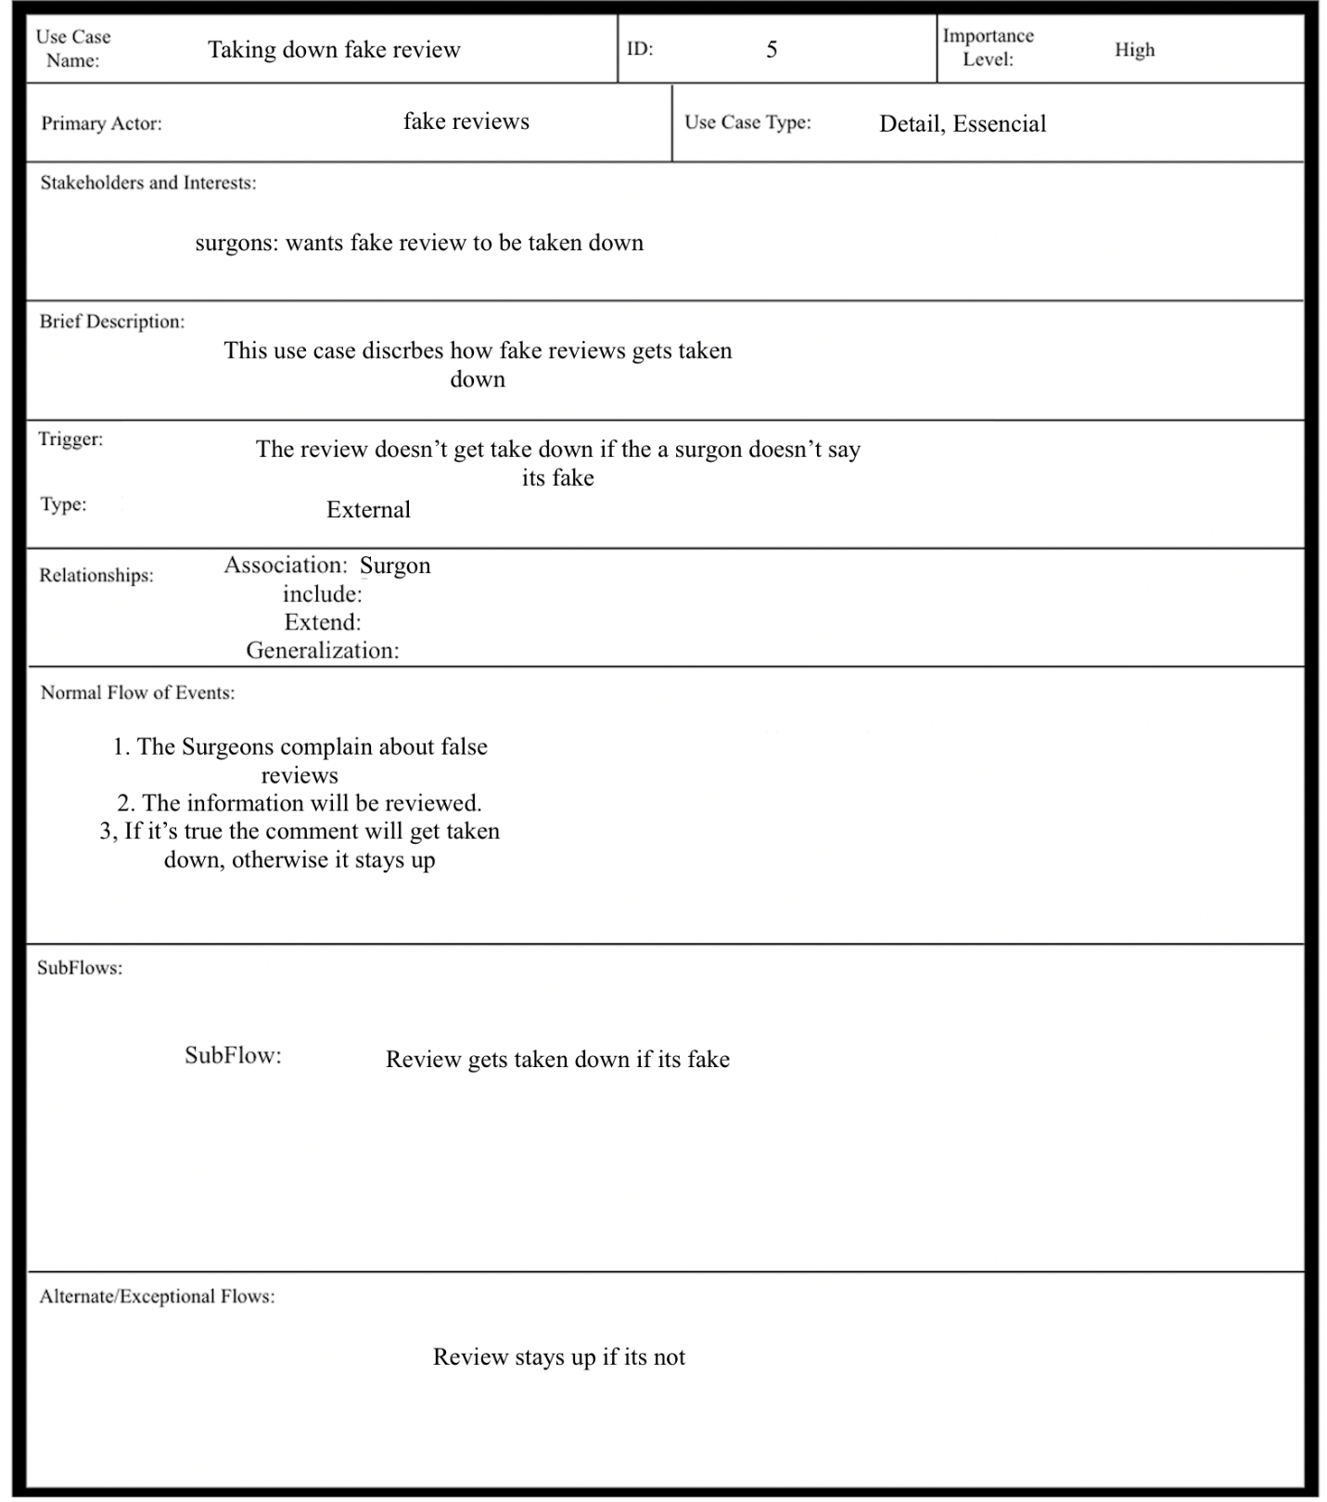

Use-Case Description #6

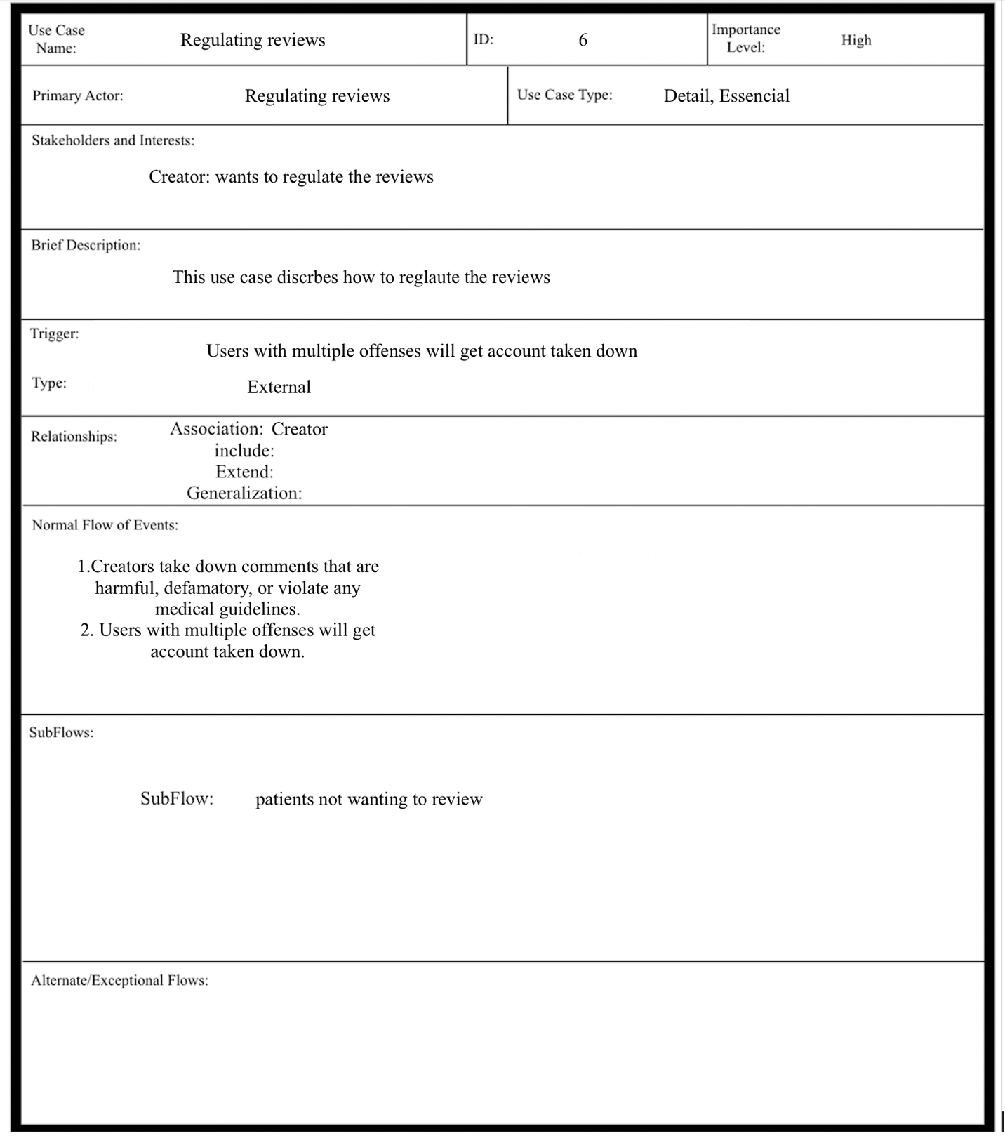

**M) Effort Estimation**



**N) CRC Cards:**

CRC Card #1

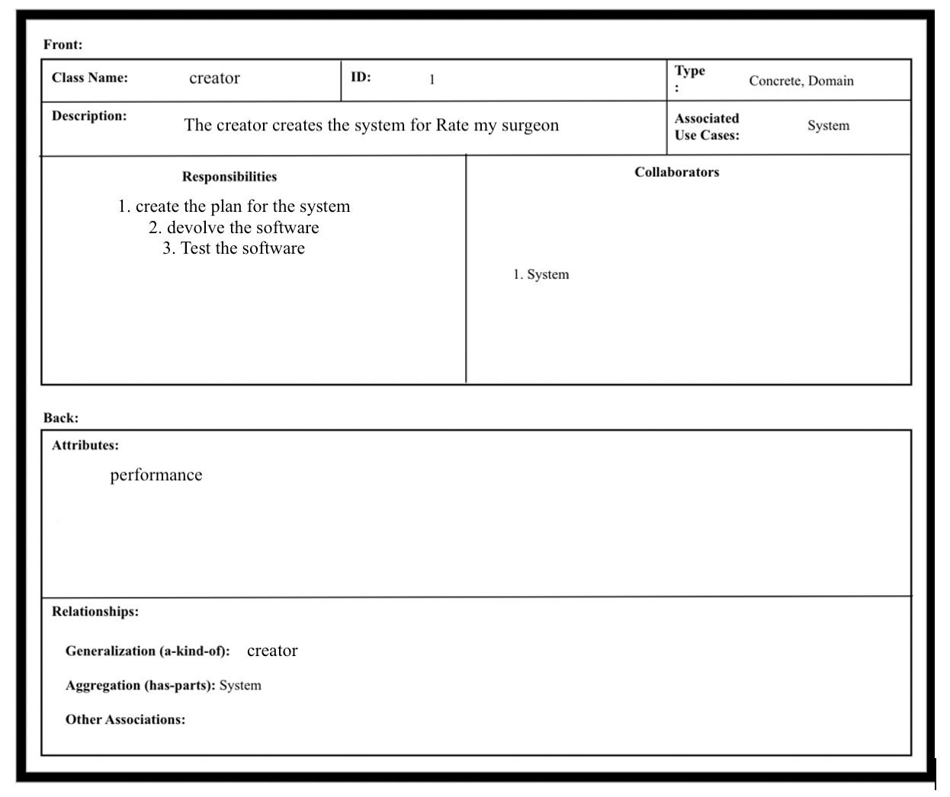

CRC Card #2

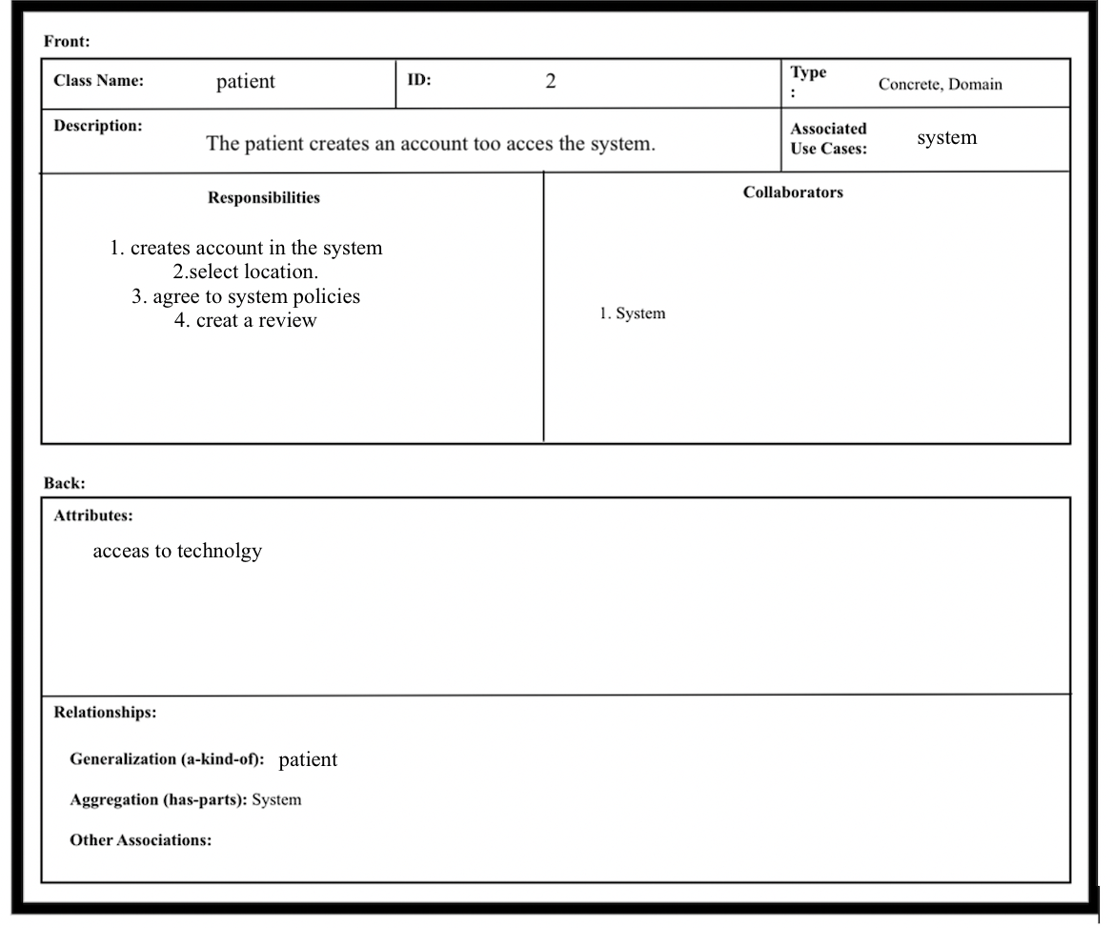

CRC Card #3

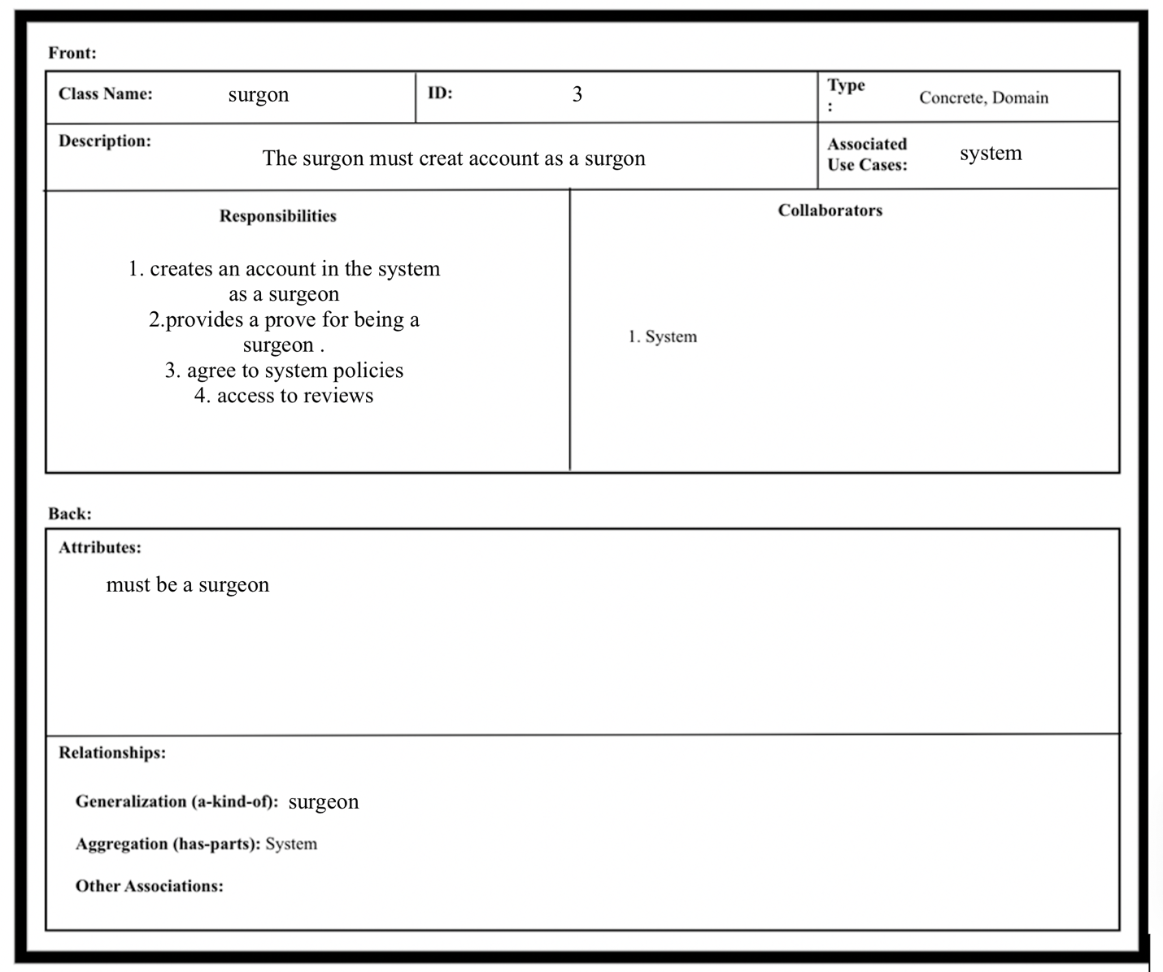

CRC Card #4

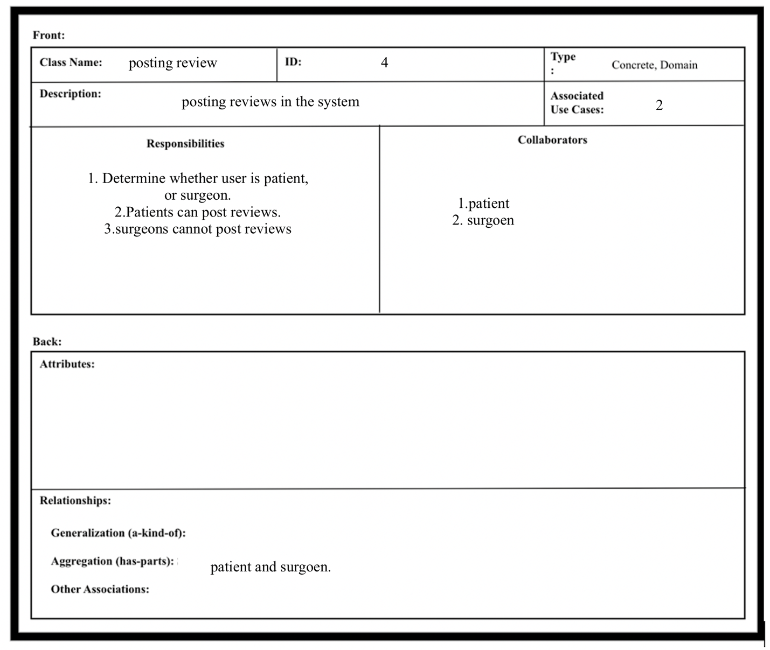

CRC Card #5

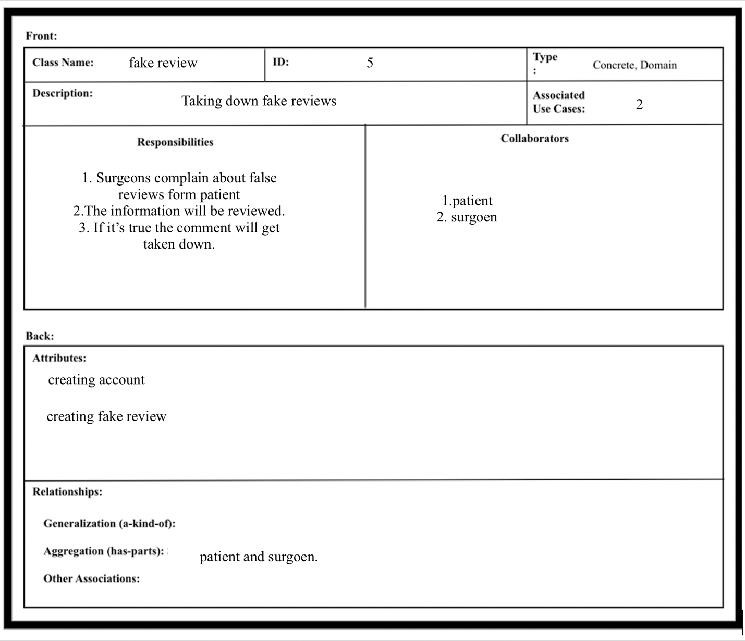

CRC Card #6

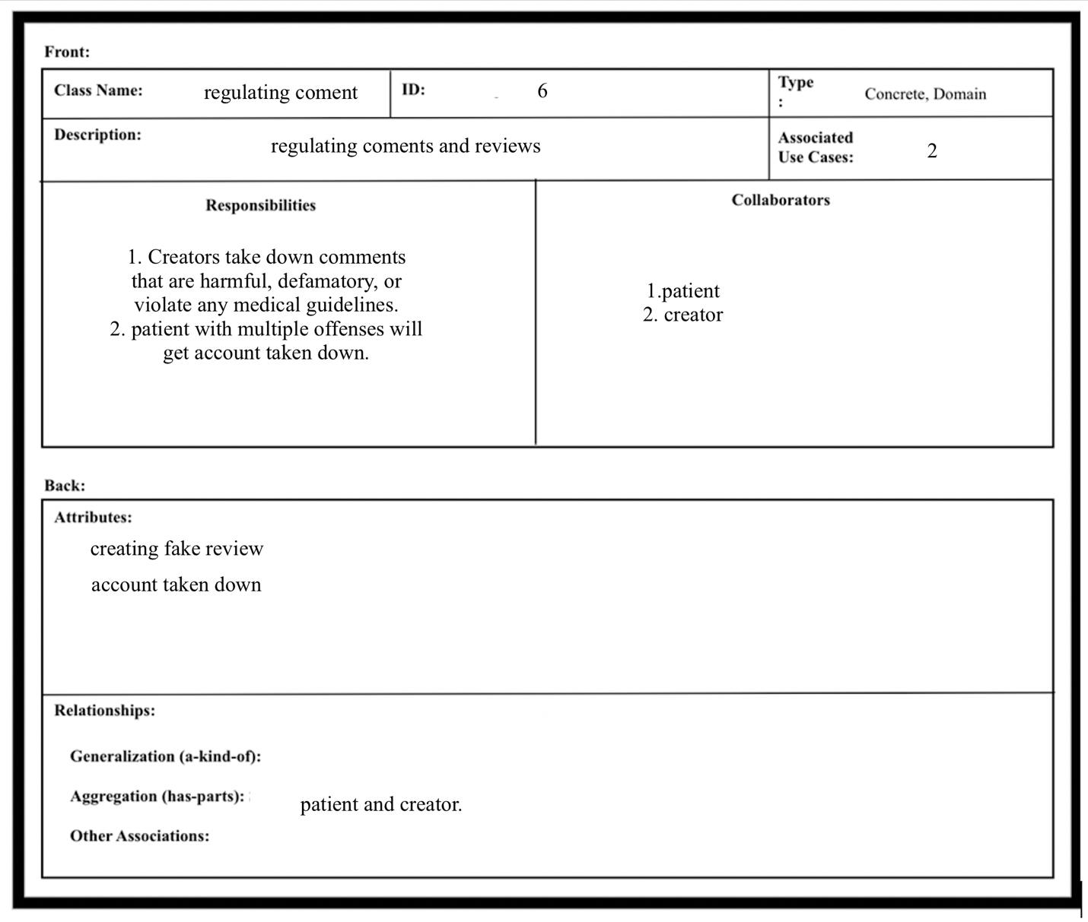

**O) Class Diagram**

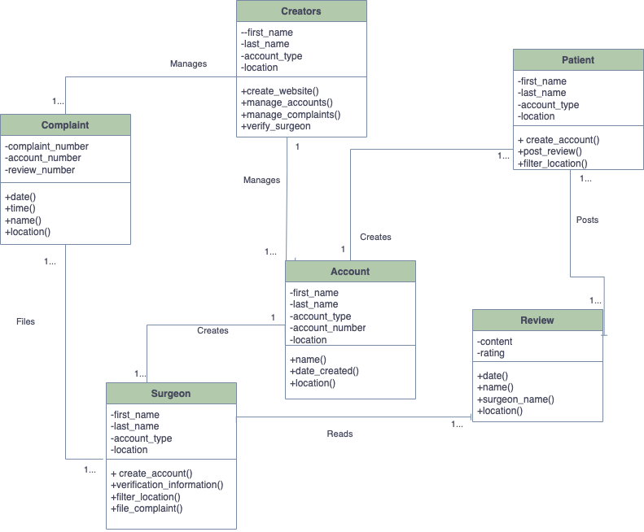

Comment

**P) Sequence Diagrams**

Sequence Diagram #1

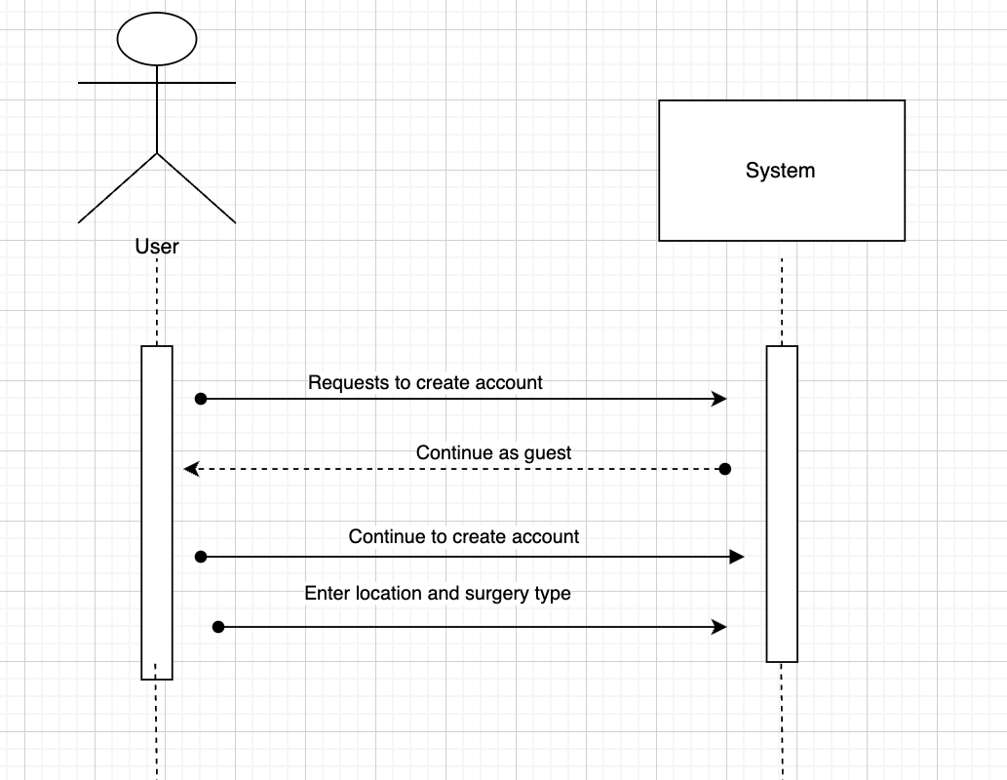

Sequence Diagram #2

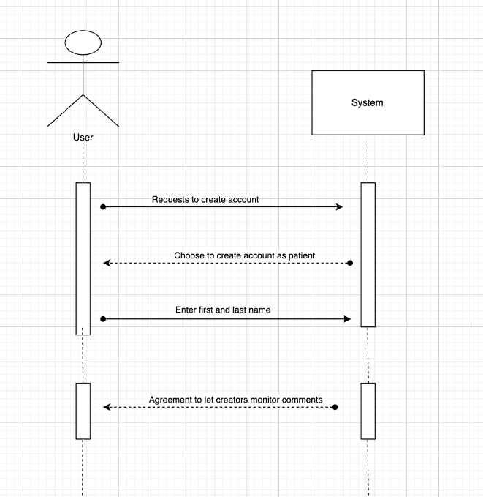

Sequence Diagram #3

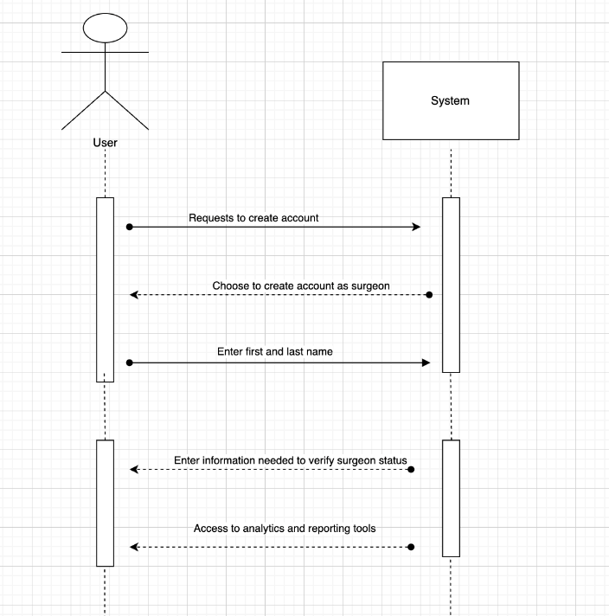

Sequence Diagram #4

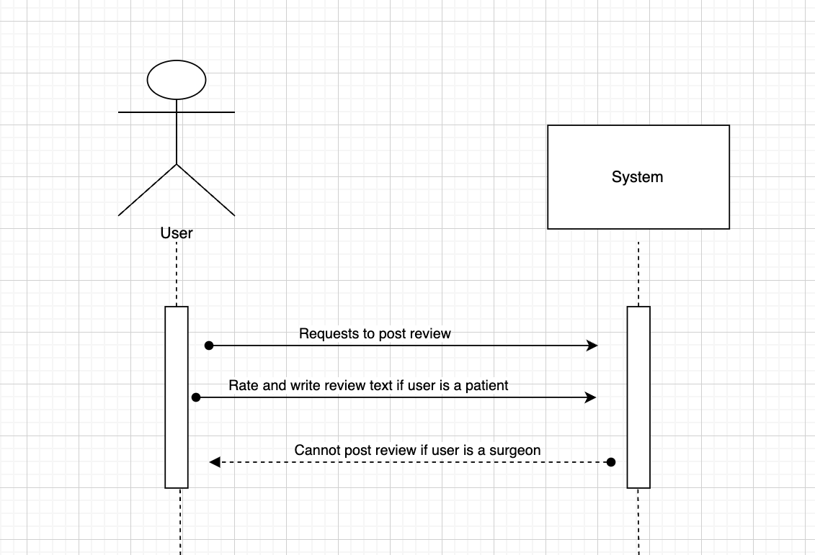

Sequence Diagram #5

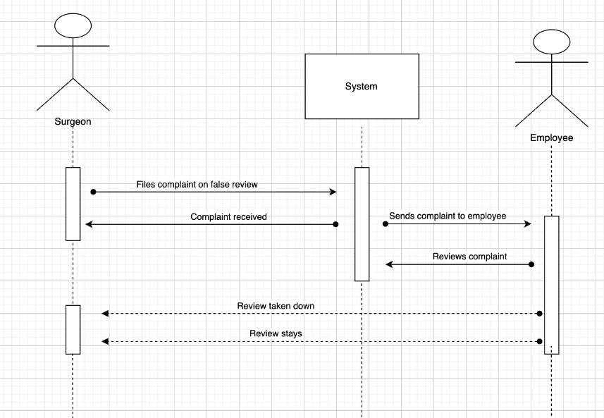

Sequence Diagram #6

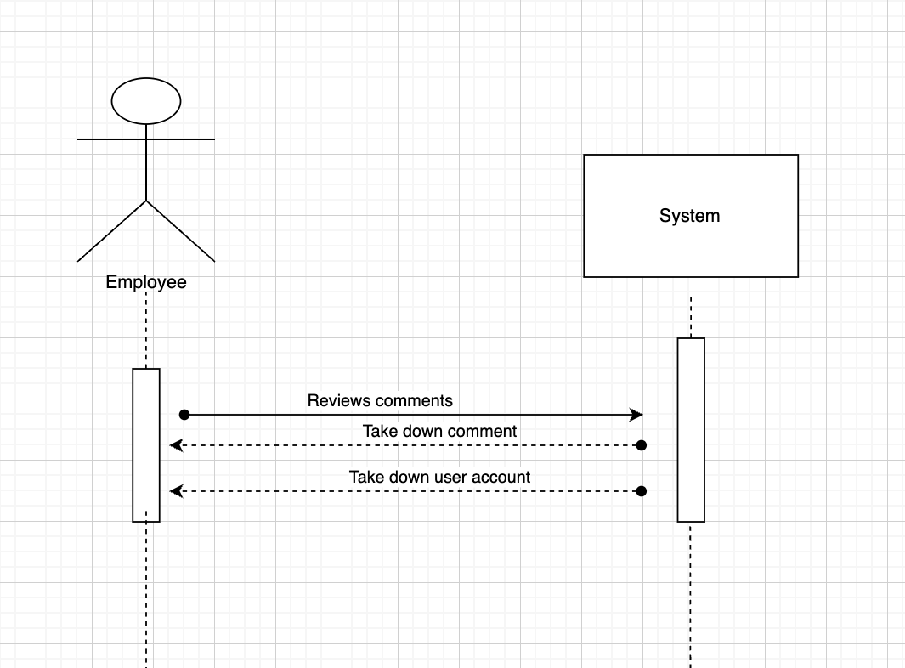

**Q) Communication Diagrams**

Communication Diagram #1

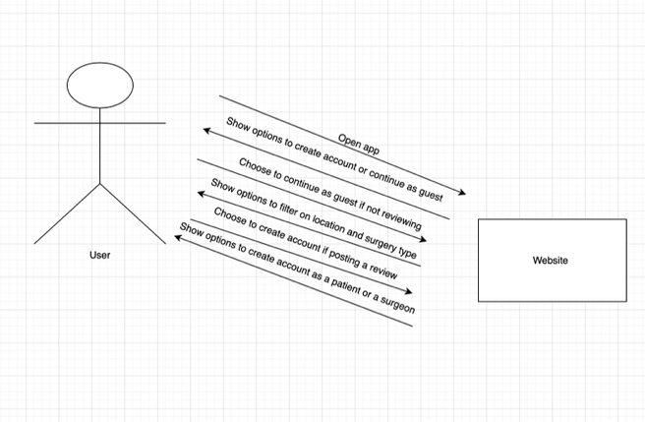

Communication Diagram #2

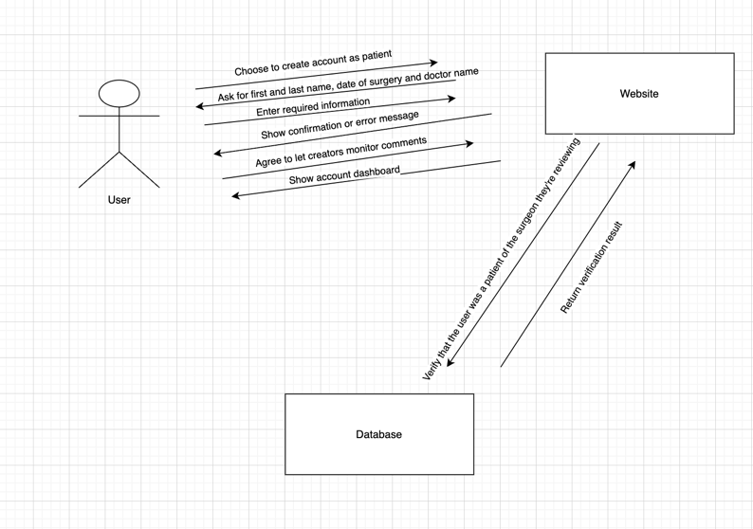

Communication Diagram #3

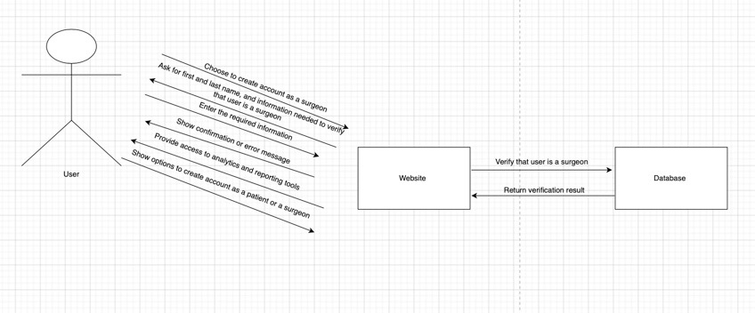

Communication Diagram #4

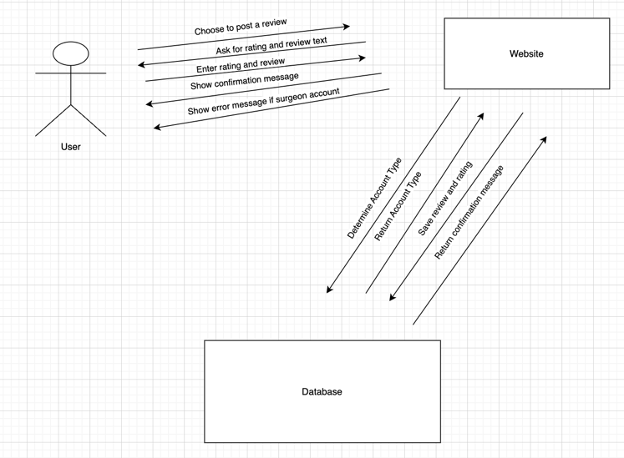

Communication Diagram #5

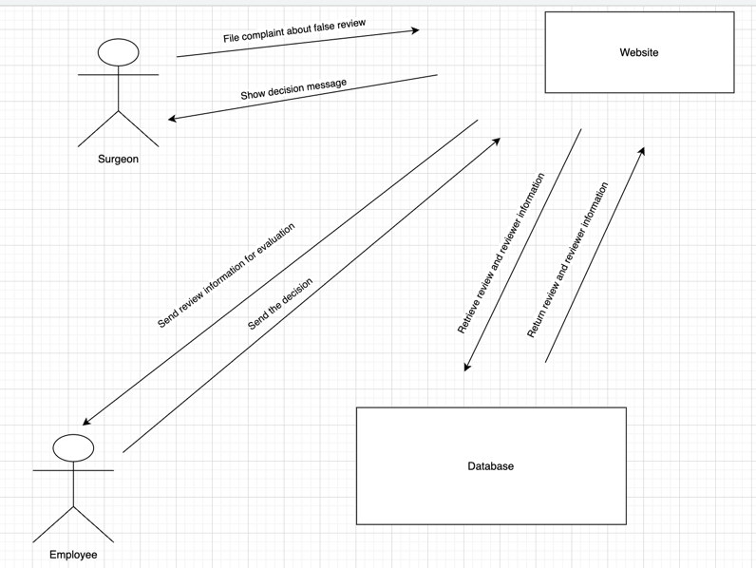

Communication Diagram #6

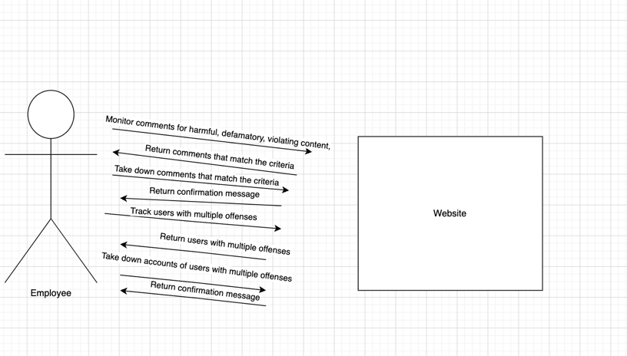

**R) Behavioral State Machine Diagrams**

Behavioral State Machine Diagram #1

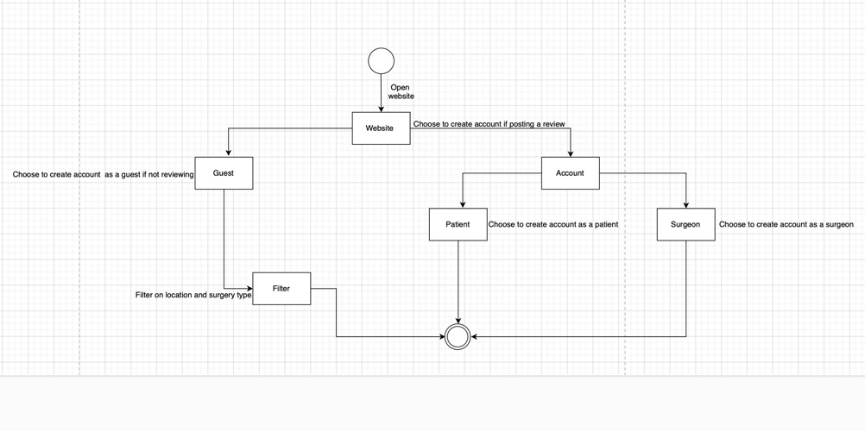

Behavioral State Machine Diagram #2

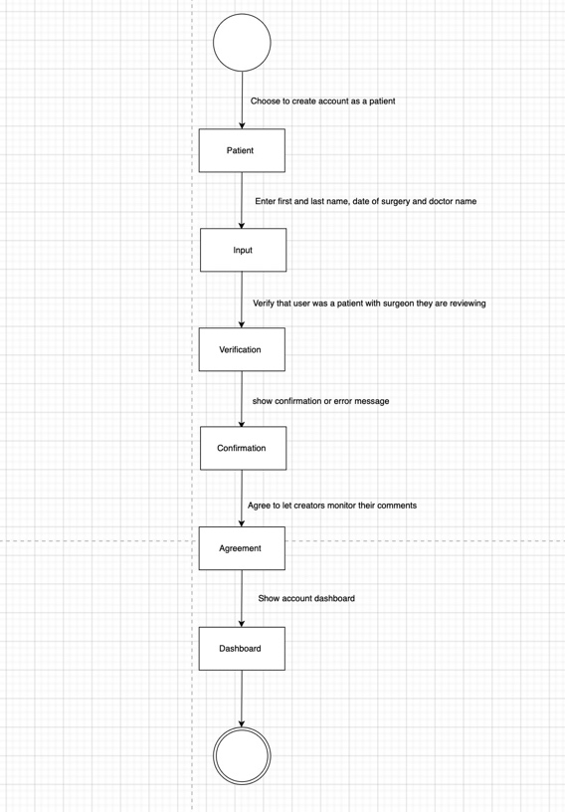

Behavioral State Machine Diagram #3

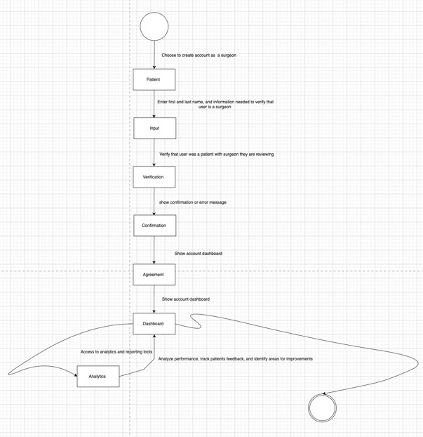

Behavioral State Machine Diagram #4

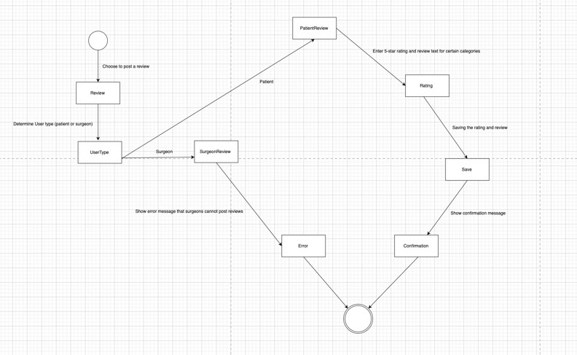

Behavioral State Machine Diagram #5

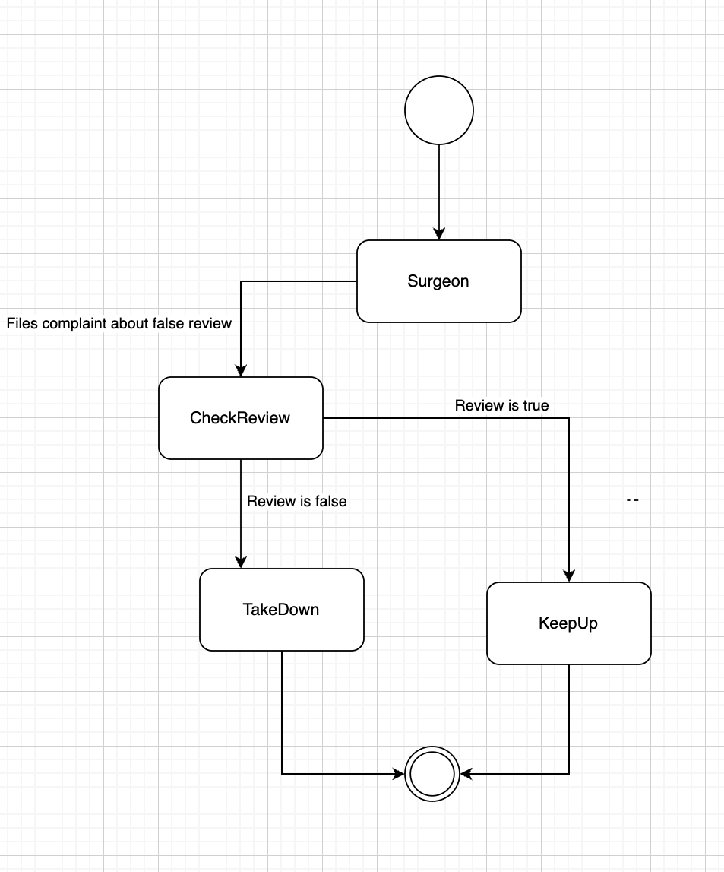

Behavioral State Machine Diagram #6

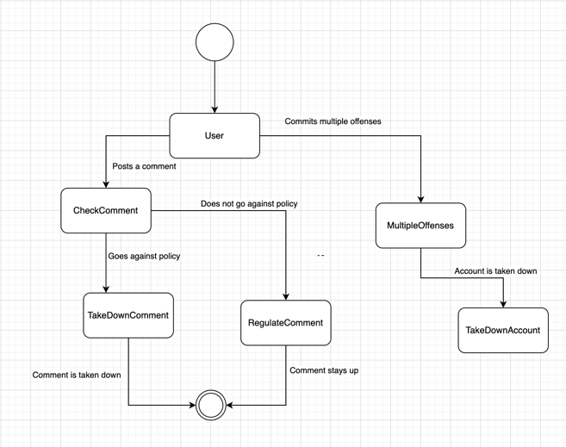

**S) Crude Matrix**

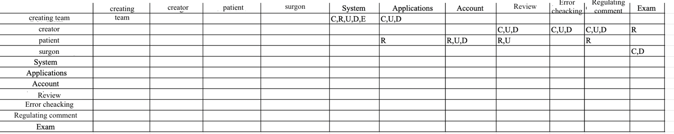

**T) Balancing report of the Functional and Structural Model**

To balance the functional and structural models of our system, they must be consistent with each other. We check the consistency by making sure that every class on a class diagram and every CRC card is associated with at least one use-case and vice versa. In our class diagram we have the creators, comments, patient, account, surgeon, and review classes. Each class has a CRC card as well as a use-case diagram. We also checked the consistency by making sure an evet in a use-case description and an activity in activity diagram are connected to operations in a class diagram. For example, taking down comments is in a use-case description for comments, and we have manage_complaints added in the class diagram. We also made sure object nodes on our activity diagrams are tied to an instance and the association/aggregation relationships are connected to use-case descriptions.

**U) Balancing report of the Functional and Behavioral Model**

To balance the functional and behavioral models of our system, they must also be consistent with each other. We check the consistency by making sure that the sequence and communication diagrams are associated with a use-case. For example, sequence diagram #1 and communication diagram #1 deal with the user creating an account and the steps they must take. They are both associated with the use-case we created. Another step we took to check the consistency is to make sure the actors in the sequence and communication diagrams are associated with the actors in our use-case. We also made sure that the messages on those diagrams are related to events in a use-case as well as activities on an activity diagram. For example, we can see the message that the surgeon files complaints in the sequence and communication diagrams as well as the use-case. Finally, we made sure that the complex objects in our activity diagrams are shown in a behavioral state machine. For example, behavioral state machine diagram #4 shows what happens if a patient posts a review as opposed to if a surgeon posts a review.

**V) Balancing report of the Structural and Behavioral Model**

To balance the structural and behavioral models of our system, they should be consistent with each other. To be sure of that, we first associated the classes with the objects in our CRUDE matrix. Second, we made sure to match each behavioral state machine with an object in a class diagram. For example, behavioral state machine diagram #3 shows the creation process of an account which matches with the account class in the class diagram. Third, the messages in our communication and sequence diagrams are related to operations in a class. The transitions in a behavioral state machine are also associated with operations in a class. For example, behavioral state machine #1 shows that a user can filter based on location and surgery type and that can be seen in the patient class filter_location. Finally, we made sure that the states in a behavioral state machine relate to the attributes of an object and its values.

**W) Action on User Recommendations**

Based on the feedback that our user role group recommended, we decided to fix our CRUDE matrix. At first it was not completely aligning with the classes in our class diagram, so we made sure to go back and fix that. We fixed the second criteria as well and confirmed that there is an association between the messages on the sequence diagram and the communication diagram. We also implemented their feedback on all other criteria we did not meet so that our behavioral model was validated.